CSS Frameworks, Responsive Layout:

* Try breaking websites down into grids, this will be the basis of any website
* Building a Framework: [**http://en.wikipedia.org/wiki/CSS\_frameworks**](http://en.wikipedia.org/wiki/CSS_frameworks)
* You can use the readily available normalize GitHub to link to your website

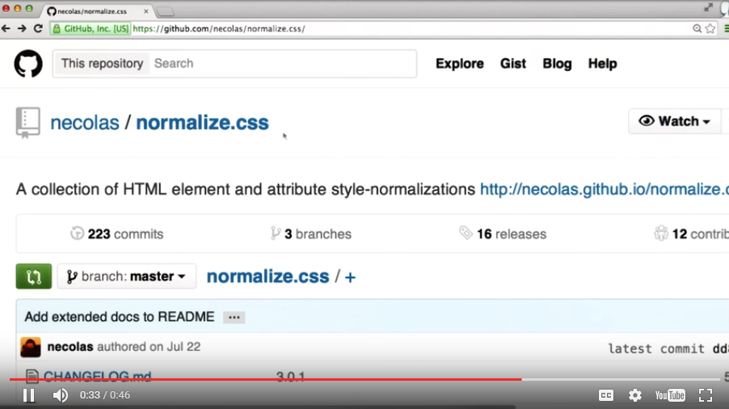

Link to the GitHub style sheet in GitHub in your HTML

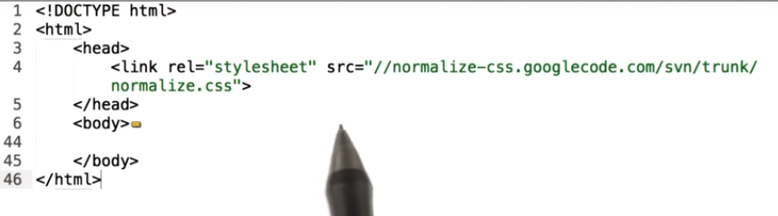

* Check Stack Over Flow for problems with errors
* You can verify your CSS and HTML with the following links
  + To verify HTML: <http://validator.w3.org/#validate_by_input>
  + To verify CSS: <http://jigsaw.w3.org/css-validator/#validate_by_input>
* The Flex property is good for allowing boxes to flow
  + Flex: <https://developer.mozilla.org/en-US/docs/Web/CSS/flex>
  + Flex Wrap: https://developer.mozilla.org/en-US/docs/Web/CSS/flex-wrap
  + Another Guide on Flex: <http://css-tricks.com/snippets/css/a-guide-to-flexbox/>
* Negative space is critical in web design. You can add this to your CSS by adding padding/margins (padding: 10px)
* You can use overflow for text with CSS text: overflow: Auto
* Gizmodo.com shows a good responsive design
* You can use placeholder images using the following URL:

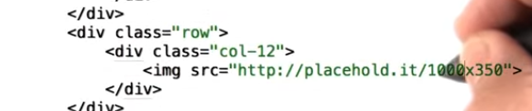

* Fonts: [www.google.com/fonts](http://www.google.com/fonts) - You must include the link into your HTML and your CSS

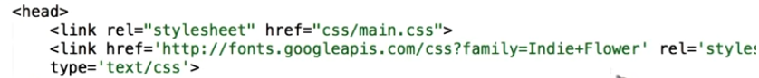

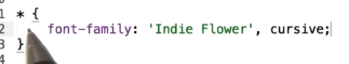

Frameworks i.e. Bootstrap

* Popular frameworks include:
  + Bootstrap: <http://getbootstrap.com/>
  + Foundation: <http://foundation.zurb.com/>
  + Yaml: <http://www.yaml.de/>
  + 960 Grid: <http://960.gs/>
  + Susy: <http://susy.oddbird.net/>
* Select only the Bootstrap components that you will need to complete your project:

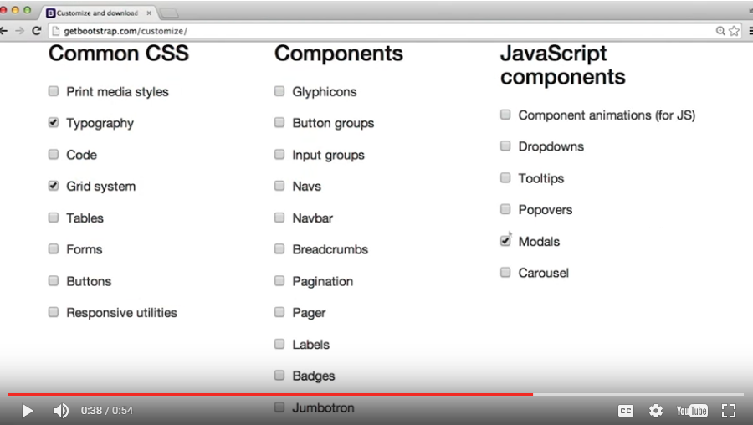

* You should always include the following lines in your heading:
  + <meta charset="utf-8">
  + <meta http-equiv="X-UA-Compatible" content="IE=edge">
  + <meta name="viewport" content="width=device-width, initial-scale=1">
* Great resource to stay on top of the latest developments in Web design: [www.alistapart.com](http://www.alistapart.com)

Why Responsive

* Build starting small and work your way up
* They use an emulator built into google chrome:
  + Command option J or control alt J
  + Hit phone icon (this is the emulator)
  + Dock the tools to the right
  + Pick the device from the list



Set the viewport:

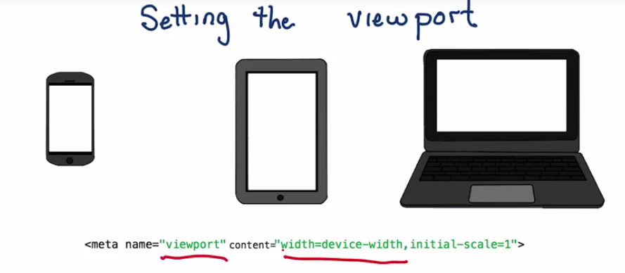

* Recommend adding a catch all in CSS:

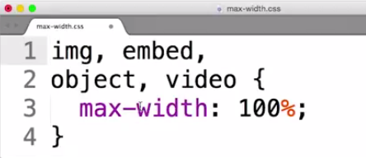

Starting Small

* Device Independent Pixels take up the same amount of space, but the device could have a density of 1+ meaning the actual pixels can be higher than you intended
* Mobile buttons should be 48\*48 pixels: min-width: 48px; min-height:48px – it won’t allow it to resize if the size is bigger than the container

Building up

* Media query apply different CSS based on the device that pulls up (stick with screen & print)
* Create an additional CSS file with media queries
* Applies when a media is over 500px:

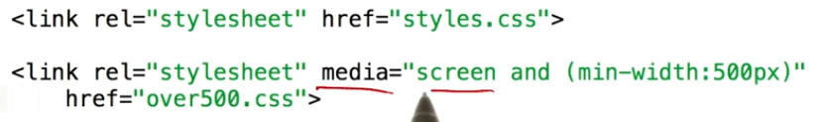

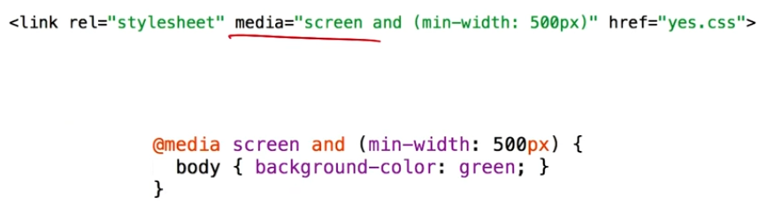

All media queries

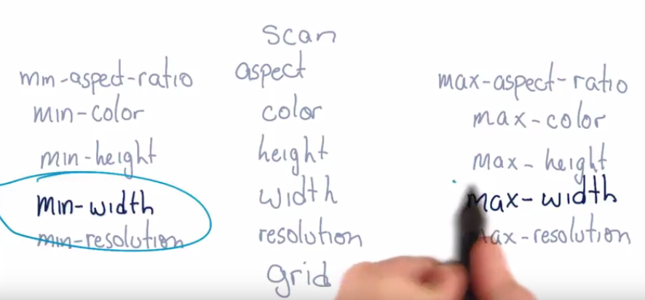

* Min-device-width and max are not recommended
* Skinnyties.com, medium.com & CNN.com for breakpoint designs
* How to determine breakpoints in your page. Let the content do that talking. You can use different style sheets for different media query results

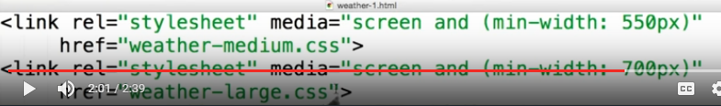

* You can use complex media queries to decide the content of your page

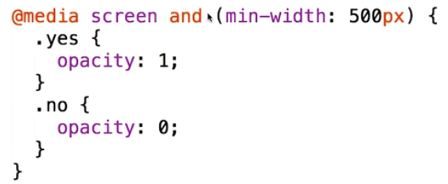

MDN: <https://developer.mozilla.org/en-US/docs/Web/CSS/Media_Queries/Using_media_queries>

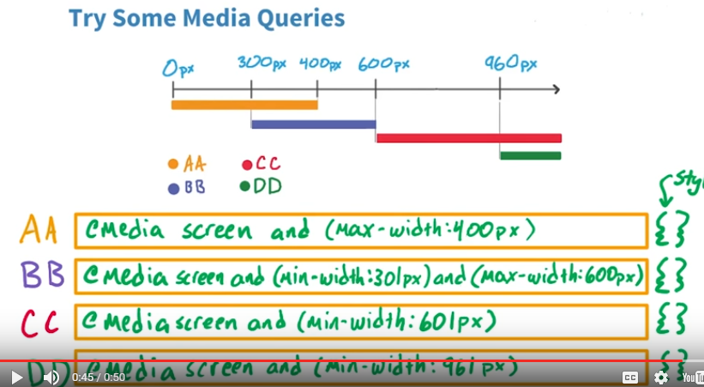

Html5rocks.com/en is an example  
The default is row

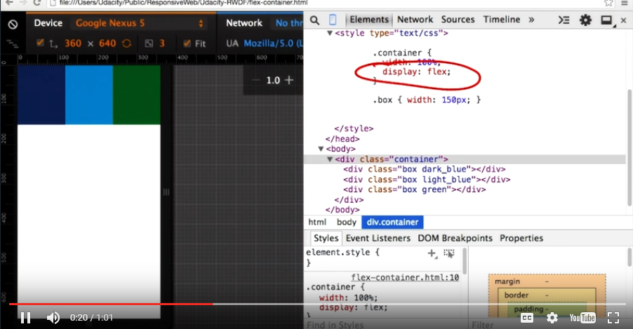

Adding flexwrap, allows divs to wrap to the next line

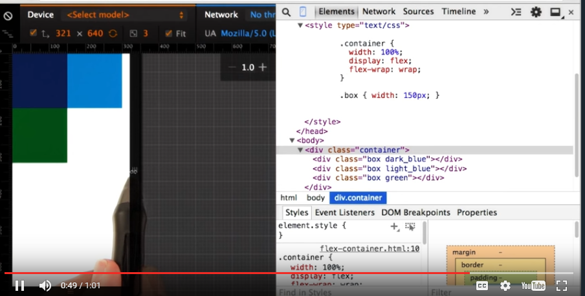

Another change is the order attribute

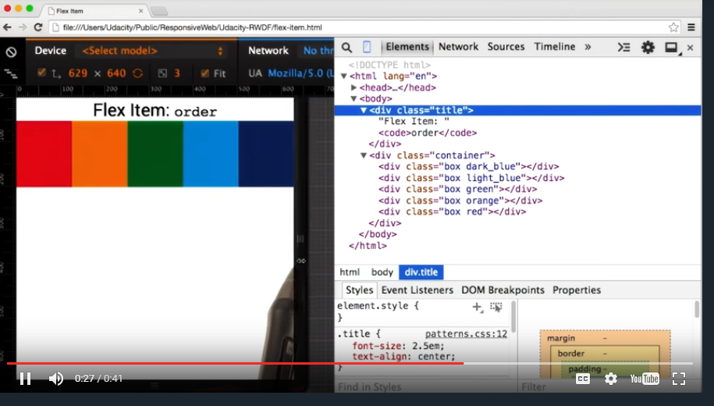

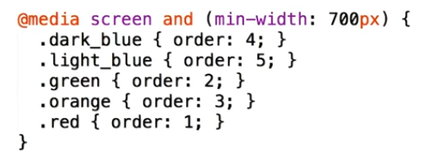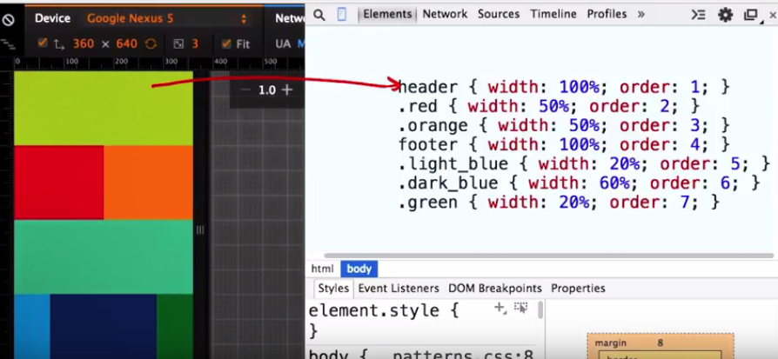

Common Responsive Patterns

|  |  |
| --- | --- |
|  |  |
|  |  |

Column Drop:

|  |  |  |
| --- | --- | --- |
|  |  |  |

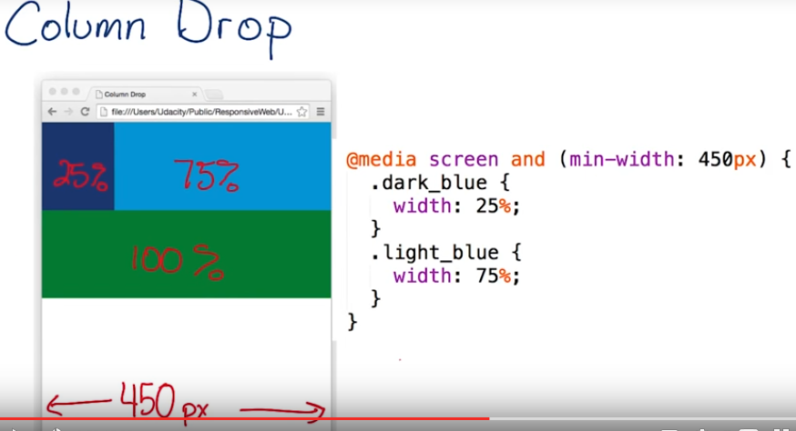

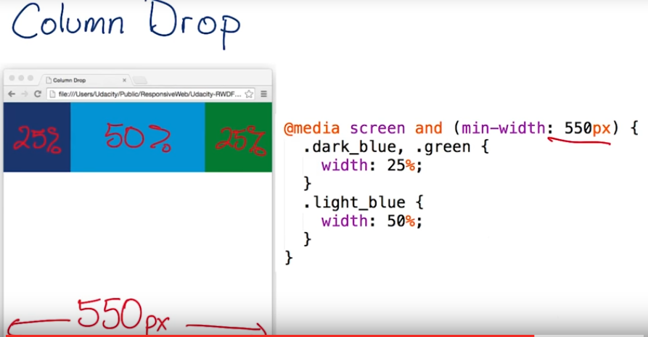

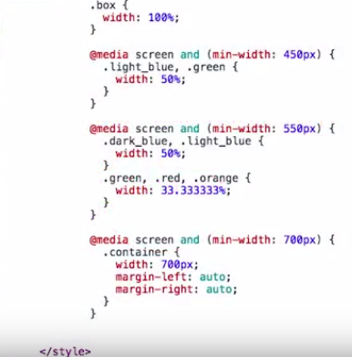

Layout Shifter:

|  |  |  |
| --- | --- | --- |
|  |  |  |

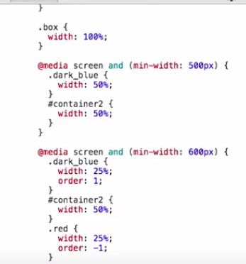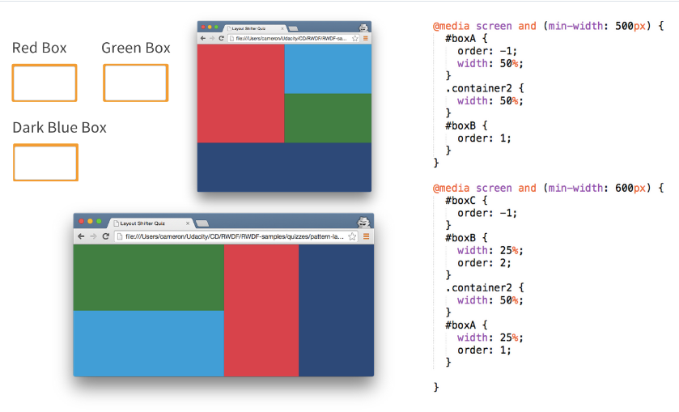

Off Canvas

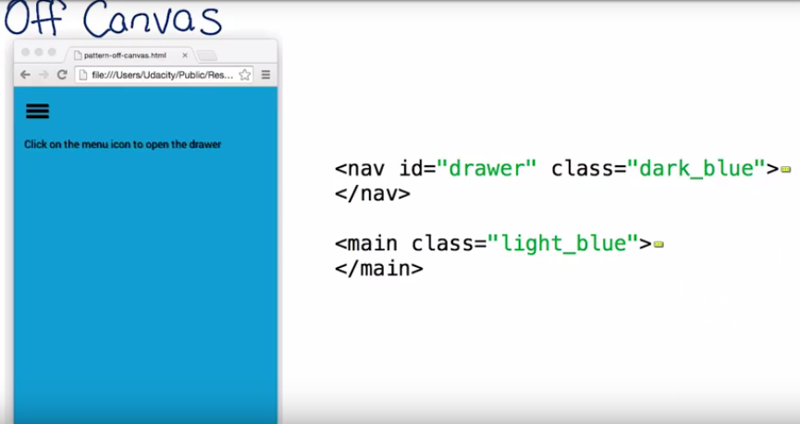

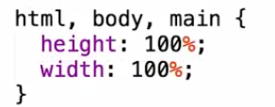

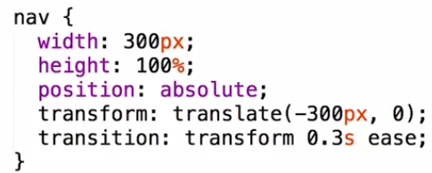

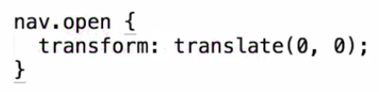

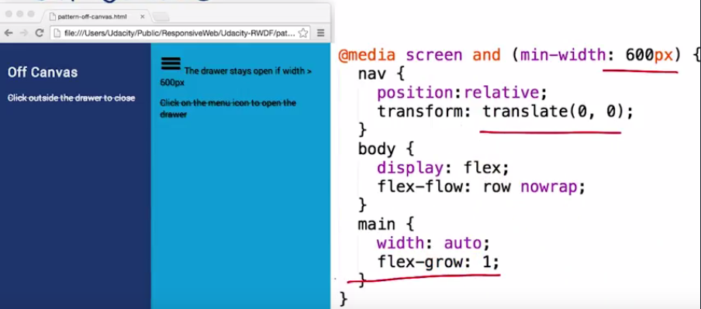

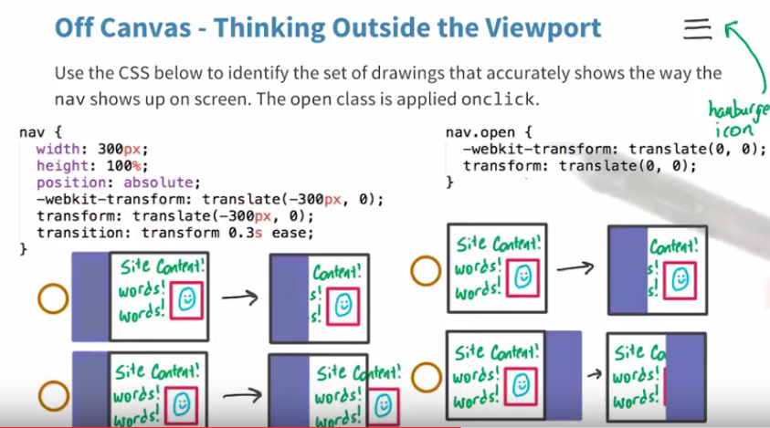

Optimizations:

* Course on responsive images: <https://www.udacity.com/course/responsive-images--ud882>
* <https://developers.google.com/web/fundamentals/design-and-ui/responsive/images>
* Responsive tables

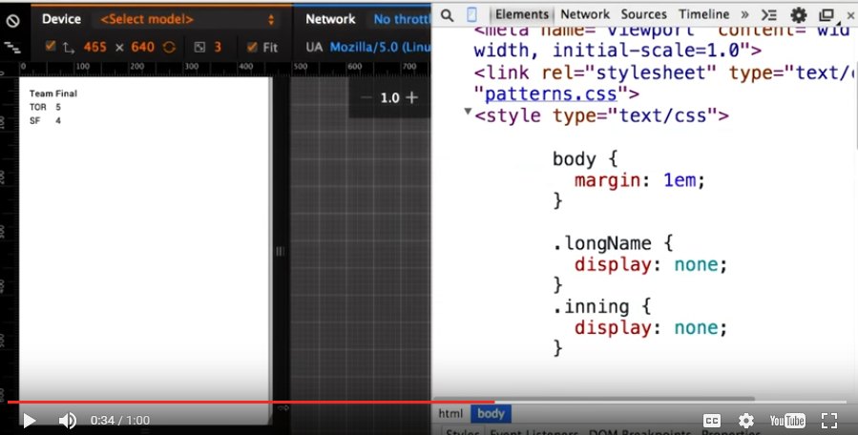\

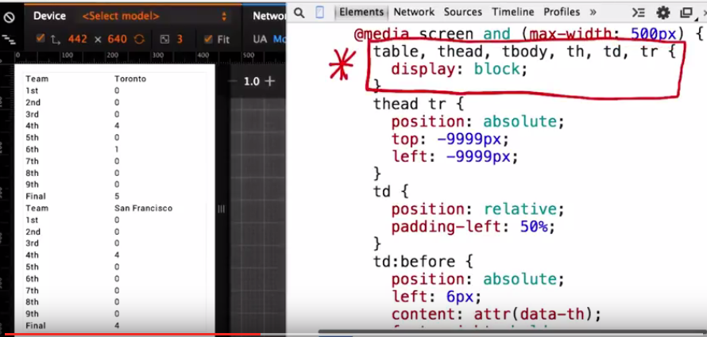

* <http://codepen.io/JohnMav/pen/BoGJNy>
* CSS Tricks: <http://css-tricks.com/responsive-data-table-roundup/>
* Easiest way to contain a table (wrap with a container, over-flow and width):

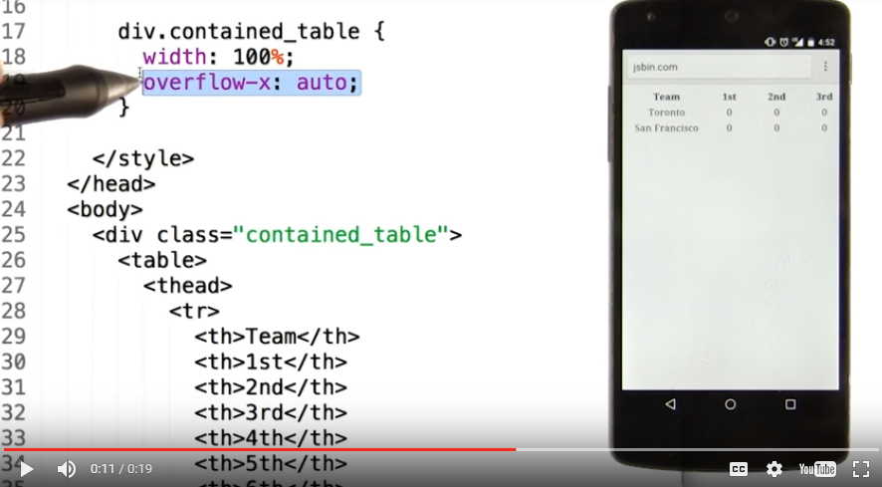

* 45-90 CPL, but a solid guide is 65 for the web
* Base font size: 16px
* line-height: 1.25em -> Increase this for Text heavy sites
* How to add ellipsis to end of texts: <https://css-tricks.com/snippets/css/truncate-string-with-ellipsis/>
* <http://hackingui.com/front-end/a-pure-css-solution-for-multiline-text-truncation/>

Units, Formats, Environments

* Total bits = pixels \* bits per pixel
* The following is a way to add a margin that is calculated. Also use the “last type” to make sure there isn’t an extra margin applied to the last image

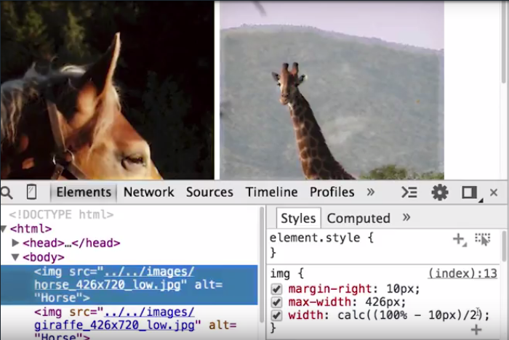

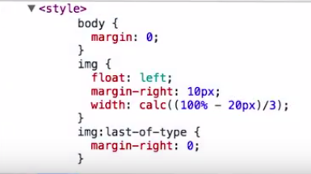

* VH, VH, VMAX, VMIN is a measurement in CSS meaning. These are used to get the viewport height.
* Best practice is to use JPEG or SVG for Vector images
* The following website will transform your photos automatically: [www.imagemagick.org](http://www.imagemagick.org)

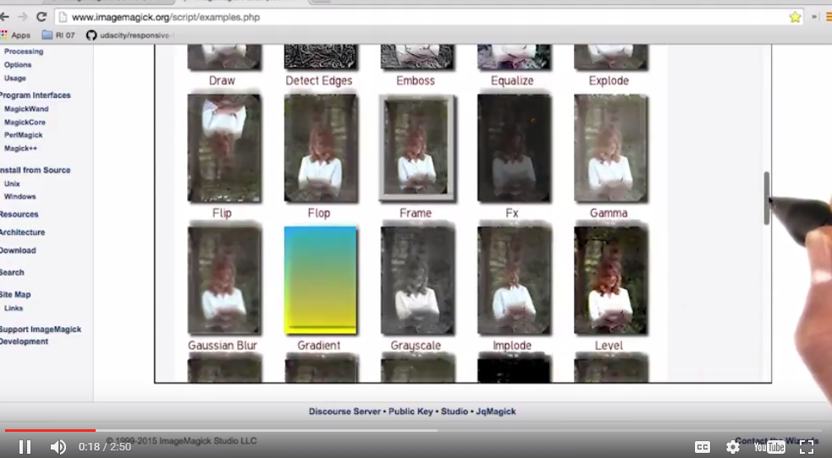

* Image Pipeline
  + Before you start automating your build process with tools like ImageMagick or ImageOptim, you will first need to [**install Node.js**](https://nodejs.org/en/download/). [**Node.js**](https://nodejs.org/en) is a JavaScript runtime built on [**Chrome's V8 JavaScript engine**](https://developers.google.com/v8/). It also comes with a package manager, **[npm](https://www.npmjs.com/" \t "_blank)**, that gives you access to thousands of code packages, like Grunt, that you can use in your projects. **Make sure you've**[**installed Node.js and updated npm**](https://docs.npmjs.com/getting-started/installing-node)**.** Then, use the links below to finish setting up your build process.
  + Install Grunt: <http://gruntjs.com/>
  + Install ImageOptim: <https://imageoptim.com/>
  + Install imageMagick
* Image Magick: <http://www.imagemagick.org/>
* Simple image (for Mac): <http://cactuslab.com/imagemagick/>
* Graphics Magick: <http://www.graphicsmagick.org/>
* Check to see if all images are optimized: developers.google.com/speed/pagesspeed/insights

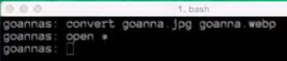

Grunt:

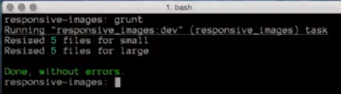

* Udacity webcast for setting up Grunt: [**Front End version**](https://classroom.udacity.com/nanodegrees/nd001/parts/0011345404/modules/273669854375463/lessons/5827851013/concepts/58278802730923) and [**Full Stack version**](https://classroom.udacity.com/nanodegrees/nd004/parts/0041345402/modules/004134540275463/lessons/5827851013/concepts/58278802730923).
* [**Getting started with Grunt**](http://gruntjs.com/getting-started)
* [**Grunt for People Who Think Things Like Grunt are Weird and Hard**](http://24ways.org/2013/grunt-is-not-weird-and-hard/)
* [**Generate multi-resolution images with Grunt**](http://addyosmani.com/blog/generate-multi-resolution-images-for-srcset-with-grunt/)
* [**grunt-responsive-images plugin for generating multiple images**](https://github.com/andismith/grunt-responsive-images)
* [**grunt-respimg plugin for a responsive image workflow**](https://www.npmjs.com/package/grunt-respimg)

Files used in scripting examples:

* [**convert.sh**](http://udacity.github.io/responsive-images/convert.sh) (includes instructions)
* [**Gruntfile.js**](http://udacity.github.io/responsive-images/Gruntfile.js) (remove line 7, engine: 'im', on Windows)
* [**Imager.js**](https://github.com/BBC-News/Imager.js/): responsive image loading developed for BBC News

Image processing tools:

* [**ImageOptim**](http://imageoptim.com/) (Mac only)
* [**Trimage**](http://trimage.org/) - Similar to ImageOptim (Windows, Mac, Linux)
* [**ImageAlpha**](https://github.com/pornel/ImageAlpha)

# Quiz: Image Optimization Environment

Before you start automating your build process with tools like ImageMagick or ImageOptim, you will first need to [**install Node.js**](https://nodejs.org/en/download/). [**Node.js**](https://nodejs.org/en) is a JavaScript runtime built on [**Chrome's V8 JavaScript engine**](https://developers.google.com/v8/). It also comes with a package manager, **[npm](https://www.npmjs.com/" \t "_blank)**, that gives you access to thousands of code packages, like Grunt, that you can use in your projects. **Make sure you've**[**installed Node.js and updated npm**](https://docs.npmjs.com/getting-started/installing-node)**.** Then, use the links below to finish setting up your build process.

ImageMagick:

* [**ImageMagick**](http://www.imagemagick.org/)
* [**Simple ImageMagick installer for Mac**](http://cactuslab.com/imagemagick/)
* [**GraphicsMagick**](http://www.graphicsmagick.org/) (a fork of ImageMagick)

Grunt:

* [**Coach JohnMav's Webcast**](https://discussions.udacity.com/t/grunt-and-setting-up-a-grunt-workflow-intermediate/21984?_ga=1.59327722.672083044.1467344711) with step-by-step instructions for setting up Grunt
* [**Getting started with Grunt**](http://gruntjs.com/getting-started)
* [**Grunt for People Who Think Things Like Grunt are Weird and Hard**](http://24ways.org/2013/grunt-is-not-weird-and-hard/)
* [**Generate multi-resolution images with Grunt**](http://addyosmani.com/blog/generate-multi-resolution-images-for-srcset-with-grunt/)
* [**Grunt plugin for generating multiple images**](https://github.com/andismith/grunt-responsive-images)

Files used in scripting examples:

* [**convert.sh**](http://udacity.github.io/responsive-images/convert.sh) (includes instructions)
* [**Gruntfile.js**](http://udacity.github.io/responsive-images/Gruntfile.js) (remove line 7, engine: 'im', on Windows)
* [**Imager.js**](https://github.com/BBC-News/Imager.js/): responsive image loading developed for BBC News

Image processing tools:

* [**ImageOptim**](http://imageoptim.com/) (Mac only)
* [**Trimage**](http://trimage.org/) - Similar to ImageOptim (Windows, Mac, Linux)
* [**ImageAlpha**](https://github.com/pornel/ImageAlpha)
* [**File Optimizer**](http://nikkhokkho.sourceforge.net/static.php?page=FileOptimizer) (Windows, Linux)

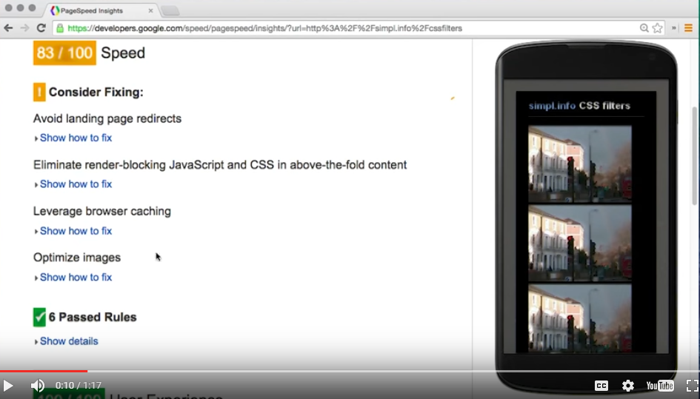

Project 1:

### Download the project files [here](http://udacity.github.io/responsive-images/downloads/RI-Project-Part-1-Start.zip).\*

Make sure to run your project through localhost. For Mac/Linux cd to your work directory and set up a [**simple HTTP server**](http://www.linuxjournal.com/content/tech-tip-really-simple-http-server-python). For Windows, see below.

Make sure you are running the **[Udacity Feedback Chrome Extension](https://chrome.google.com/webstore/detail/udacity-front-end-feedbac/melpgahbngpgnbhhccnopmlmpbmdaeoi" \t "_blank)** to get feedback.

Open the console to see the total size of all of your images!

### [Learn more about the figure tag!](https://developer.mozilla.org/en-US/docs/Web/HTML/Element/figure)

### Setting up Build Process

Before you start automating your build process with tools like ImageMagick or ImageOptim, you will first need to [**install Node.js**](https://nodejs.org/en/download/). [**Node.js**](https://nodejs.org/en) is a JavaScript runtime built on [**Chrome's V8 JavaScript engine**](https://developers.google.com/v8/). It also comes with a package manager, **[npm](https://www.npmjs.com/" \t "_blank)**, that gives you access to thousands of code packages, like Grunt, that you can use in your projects. **Make sure you've**[**installed Node.js and updated npm**](https://docs.npmjs.com/getting-started/installing-node)**.** Then, use the links below to finish setting up your build process.

ImageMagick:

* [**ImageMagick**](http://www.imagemagick.org/)
* [**Simple ImageMagick installer for Mac**](http://cactuslab.com/imagemagick/)
* [**GraphicsMagick**](http://www.graphicsmagick.org/) (a fork of ImageMagick)

Grunt:

* [**Getting started with Grunt**](http://gruntjs.com/getting-started)
* [**Grunt for People Who Think Things Like Grunt are Weird and Hard**](http://24ways.org/2013/grunt-is-not-weird-and-hard/)
* [**Generate multi-resolution images with Grunt**](http://addyosmani.com/blog/generate-multi-resolution-images-for-srcset-with-grunt/)
* [**Grunt plugin for generating multiple images**](https://github.com/andismith/grunt-responsive-images)

Files used in scripting examples:

* [**convert.sh**](http://udacity.github.io/responsive-images/convert.sh) (includes instructions)
* [**Gruntfile.js**](http://udacity.github.io/responsive-images/Gruntfile.js) (remove line 7, engine: 'im', on Windows)
* [**Imager.js**](https://github.com/BBC-News/Imager.js/): responsive image loading developed for BBC News

Image processing tools:

* [**ImageOptim**](http://imageoptim.com/) (Mac only)
* [**Trimage**](http://trimage.org/) - Similar to ImageOptim (Windows, Mac, Linux)
* [**ImageAlpha**](https://github.com/pornel/ImageAlpha)

Feel Free to follow this [**article**](http://www.aspdotnet-suresh.com/2015/02/empty-missing-binding-type-in-iis-8-in-windows8.html) to learn more about **running localhost on windows**. If the article is unhelpful please follow the advice below

Student ("James") suggested instructions for running localhost on windows:

**First you must turn on IIS:**

Start>Control Panel>Programs>Turn Windows features on or off

The Windows Features box will appear. It may take a while for it to load

Scroll down and find Internet Information Services and ensure the box is clicked. Underneath that is Internet Information Services Hostable Web Core. Click that box as well.

**Second you must open the Internet Information Services (IIS) Manager and configure IIS**

Click the Start button and type IIS in the search bar

Click on Internet Information Services (IIS) Manager to open

In the left Connections pane click the little arrowhead to open the tree and right click on the Sites folder

Click Add Web Site

Give the site a name, and add the path to the folder where your website is located.

Go to the IP address and click the drop down. Find the IP address (ex. 192.168.0.92). (write this down somewhere. I put it as comments in my html and css files)

Pick a port. I don't recommend using port 80 but any other should do. I used 90

click ok.

**Third, set read permissions on the website folder**

Right-click on the folder your website is kept on and click on properties

Go to the security tab and scroll through Group or user names and look for the following:

IUSR and IIS\_IUSRS

If they are there, be sure that "read & execute" and "read" are checked. If they are there and not checked click on on of them and then click edit. check the box for read & execute and read. Click apply then click ok.

If they are not there then click edit and then Add. This brings up the Select Users or Groups box.

Click the Advanced Button and then the Find Now button. Scroll down until you find IIS\_IUSRS. Click on it and press OK 2 times. Click apply.

Repeat for IUSR

**To bring up website on local host**

Open Chrome and type in the IP address and port like this:

192.168.0.142:90 (or whatever your port number is)

I hope this helps. Good luck

Student ("Alexander") also recommends this video for Windows Setup:

[**https://www.youtube.com/watch?v=A\_0SqnOPSng**](https://www.youtube.com/watch?v=A_0SqnOPSng)

Changing security/permissions for IIS\* files/folders

## \*Microsoft Internet Information Services (IIS)

## Feel Free to follow this [article](http://www.aspdotnet-suresh.com/2015/02/empty-missing-binding-type-in-iis-8-in-windows8.html) to learn more about **running localhost on windows**. If the article is unhelpful you are welcome to try [Fenix](http://fenixwebserver.com/) to quickly host your project or you can give the advice below a try.

### Download the project [here](http://udacity.github.io/responsive-images/downloads/RI-Project-Part-1-Solution.zip) instead!

For the Project Part 1 Tests, 3rd item "Page bytes are under 1.5MB (refresh to update)" will work properly if you run your own webserver. From your terminal (mac/linux):

1. change directories to where your index.html file is
2. run a web server, such as python -m SimpleHTTPServer 8080
3. view the page, going to this URL [**http://localhost:8080/**](http://localhost:8080/)

Grunt task to scale and compress:

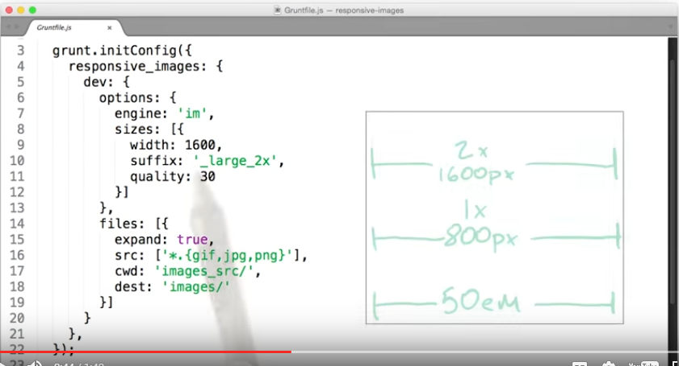

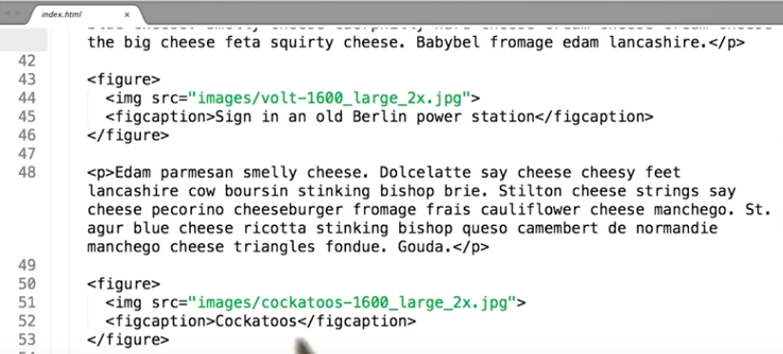

# Images with Markup:

### [Div with background image](http://udacity.github.io/responsive-images/examples/2-06/divWithBackgroundImage)

### [CSS background-size: cover](http://udacity.github.io/responsive-images/examples/2-06/backgroundSizeCover)

### [Body with background image](http://udacity.github.io/responsive-images/examples/2-06/bodyWithBackgroundImage)

### [Body with background image and gradient](http://udacity.github.io/responsive-images/examples/2-06/bodyWithBackgroundImageAndGradient)

### [Body with elaborate background using only CSS](http://udacity.github.io/responsive-images/examples/2-06/bodyWithElaboratePatternPureCSS)

### [Using CSS background images for conditional image display](http://udacity.github.io/responsive-images/examples/2-06/backgroundImageConditional)

### [Using CSS background images for alternative images](http://udacity.github.io/responsive-images/examples/2-06/backgroundImageAlternative)

### [image-set()](http://udacity.github.io/responsive-images/examples/2-06/imageSet)

contain keeps the entire image while the cover cuts some of the side off

Kola site: <http://udacity.github.io/responsive-images/examples/2-06/backgroundImageConditional/index.html>

Unicode Character Sets: <http://unicode-table.com/en/sets/>

<http://en.wikipedia.org/wiki/List_of_Unicode_characters>

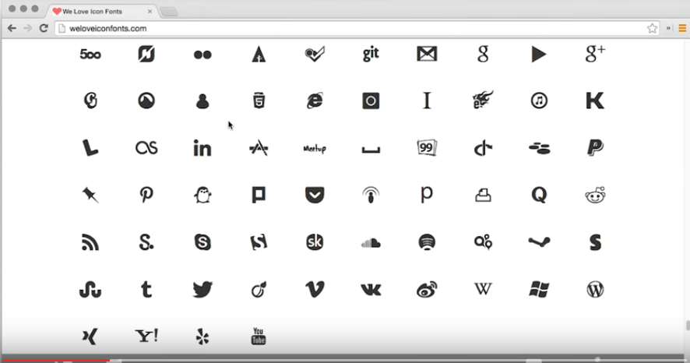

Icon Fonts:

### [Zocial](http://zocial.smcllns.com/)

### [Font Awesome](http://fortawesome.github.io/Font-Awesome/)

### [We Love Icon Fonts!](http://weloveiconfonts.com/)

### [Icon fonts on CSS-Tricks](https://css-tricks.com/examples/IconFont/)

### [ARIA](https://developer.mozilla.org/en-US/docs/Web/Accessibility/ARIA)

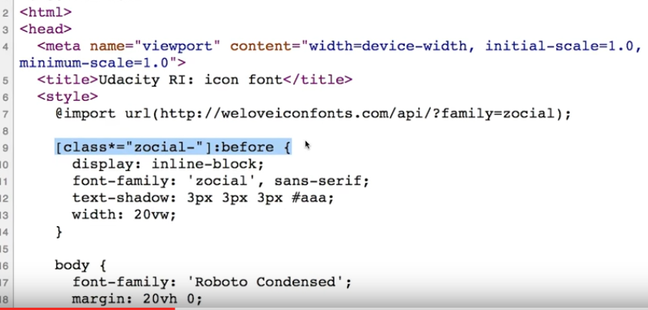

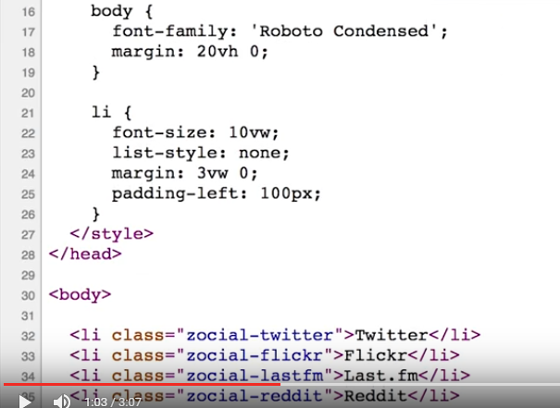

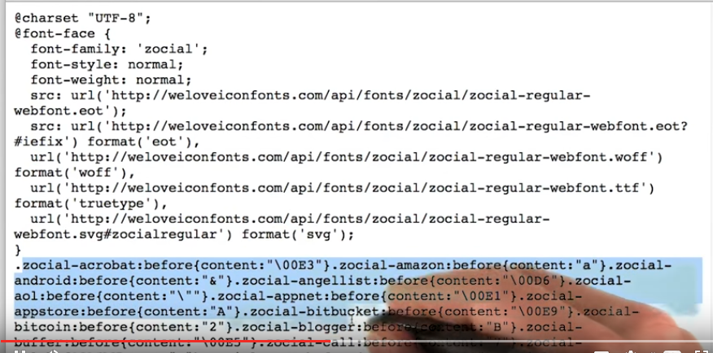

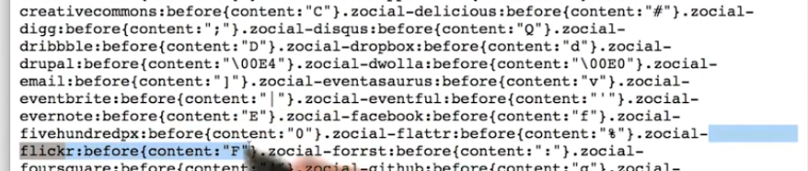



Inclining Images with SVG and Data URL’s

Examples:

* [**SVG Data URI in HTML**](http://udacity.github.io/responsive-images/examples/2-11/svgDataUri)
* [**SVG Data URI in CSS**](http://udacity.github.io/responsive-images/examples/2-11/svgDataUriCss)
* [**SVG text on a path**](http://udacity.github.io/responsive-images/examples/2-11/svgTextOnAPath)
* [**SVG optimized and unoptimized**](http://udacity.github.io/responsive-images/examples/2-11/svgUnoptimisedAndOptimised)

[**Browser support for inline SVG**](http://caniuse.com/#feat=svg-html5)

[**Browser support for Data URIs**](http://caniuse.com/datauri)

[**SVG Optimiser**](http://petercollingridge.appspot.com/svg-optimiser)

[**Trajan's Column SVG example**](http://upload.wikimedia.org/wikipedia/commons/6/6c/Trajans-Column-lower-animated.svg)

[**20 examples of SVG that will make your jaw drop**](http://www.creativebloq.com/design/examples-svg-7112785)

[**SVG animation examples**](http://codepen.io/chrisgannon/)

Full responsive

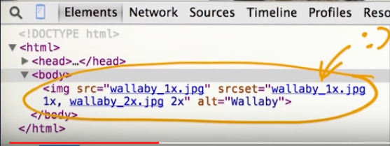

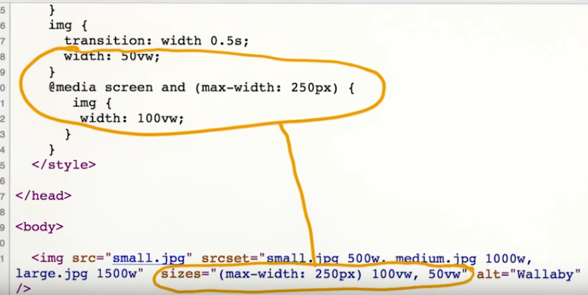

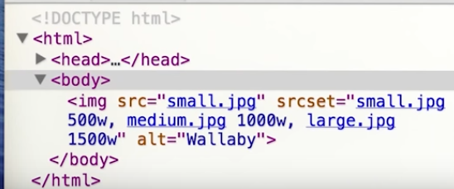

Sizes

[**A fun article on srcset**](http://ericportis.com/posts/2014/srcset-sizes/) (Warning: A little bit of NSFW language)

[**Device pixel density list**](http://pixensity.com/list/phone)

[**More information about working with pixel density**](http://www.html5rocks.com/en/mobile/high-dpi/)

[**Working with h units**](https://github.com/ResponsiveImagesCG/picture-element/issues/86)

[**Wikipedia wallabies**](https://en.wikipedia.org/wiki/Wallaby)

Sources Website:

<http://udacity.github.io/responsive-images/examples/srcsetAndSizes/index-quiz1-solution.html>

<http://udacity.github.io/responsive-images/examples/srcsetAndSizes/index-quiz2-solution.html>

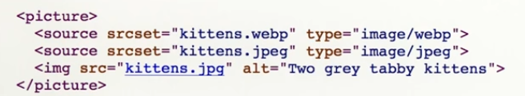

<http://udacity.github.io/responsive-images/examples/3-06/pictureAlternativeFormats>

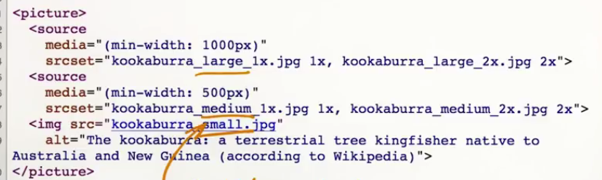

### [Here's Lynx](http://invisible-island.net/lynx/)

### [Here's ChromeVox](http://www.chromevox.com/)

### [Here's the site Cam uses](http://udacity.github.io/responsive-images/examples/3-04/forARIA/index.html)